Version

1

Braille Simulation Software

User Manual

Getting Started

Chapter

1

Usage Guidelines

t

his software was made as an educational tool for visually impaired students. By emulating the behavior of braille cells, this software allows for the creation of interactive ‘scenarios.’ These scenarios are driven by the actions of the students via a braille interface. The usage of interactive scenarios in education allows for students to read and learn the language of braille in a fun and involved setting. Educators are encouraged to create their own custom scenarios with this software, the process of which is detailed throughout this manual. The robust scenario creation platform ensures you will be able to make highly functional and customized scenarios for your students. The scenario authoring software creates scenarios which can be interfaced with braille supporting hardware like Treasure Box Braille.

# Installation Instructions

The software can be downloaded from our GitHub vM release. After it has been downloaded, double click the AuthoringApp JAR file and you will immediately be presented with the main menu screen. From here, you may begin to use the software.

# Scenarios

###### Factory Scenarios This software includes three basic factory created scenarios for you to test out yourself.

Scenarios are the focus of this software. They serve as the tools one can use to interact with the braille device simulator or TBB hardware. Scenarios are interactive sequences of events that are delivered to the user. A scenario can be created with our authoring app, which supports:

1. Decision making that drives the scenario forward
2. Text to speech and braille cell display

# Playing a Scenario

Scenarios can be tested and played inside the software using the TBB hardware simulator. It is easily accessible from the Main Menu. Select “Play a Scenario.”

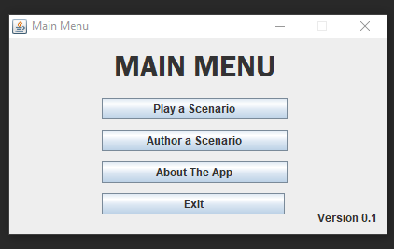

From here, you will be prompted to select a scenario file:

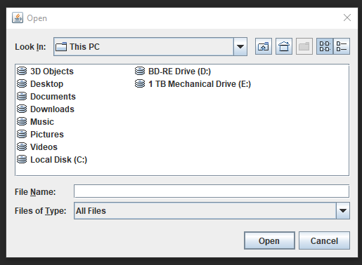

After selecting the appropriate scenario file, the simulation will begin and the scenario will start to unfold. If there is an error in your scenario file, then the software will alert you of this. Try running one of the three included factory scenarios to ensure everything is working correctly.

# Creating a Scenario

To create a scenario, select “Author a Scenario” from the Main Menu. A dialog window will appear:

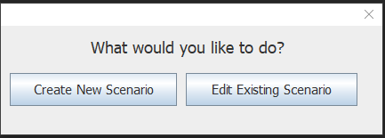

You may edit an already existing Scenario by selecting the “Edit Existing Scenario” button and choosing a Scenario file. Doing this will populate the Scenario Editor with the details of the given Scenario, ready for you to modify. For the sake of this user manual, we will walk you through the Scenario Editor as if you are creating a new Scenario from scratch. Selecting the “Create New Scenario” button will take you to the Scenario Editor, your blank canvas for creating a Scenario.

###### Scenario Title The Title of your Scenario is not the name of the Scenario file. Regardless of the file name, the Title is what will be spoken to the user upon playing your scenario.

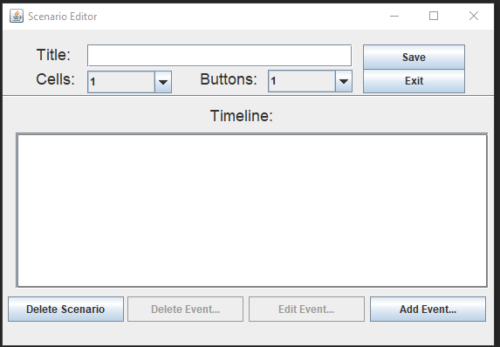

The Scenario Editor contains all the attributes of the Scenario you wish to create (or modify). The top portion of the window is where you may choose the fundamental properties of your Scenario, like the title of the Scenario, and the number of Braille Cells and Answer Buttons to display to the user. The rest of the window is where the Scenario Timeline exists. Here, you will be able to see a timeline of Events in your Scenario listed in chronological order. From the Timeline you can add or insert new Events as well as delete existing ones. The Timeline will maintain the chronology of Events according to your specification. We will start by adding our first Event to our Scenario. To do this, we can select “Add Event…” which will open the Event Editor.

# Creating an Event

The Event Editor is where you can create and edit existing Events within your Scenario. The Event Editor supports standard questions and responses. It also allows you to display up to 8 fully customizable Braille Cells.

###### Event Indexing You may enter any number as the index, negative or otherwise, as indexing is purely relative. That is to say, one event may have an index of -1, and the other an index of 999 – if those are the only two events in the Scenario, they will play in order of increasing index regardless of the numerical difference in index.

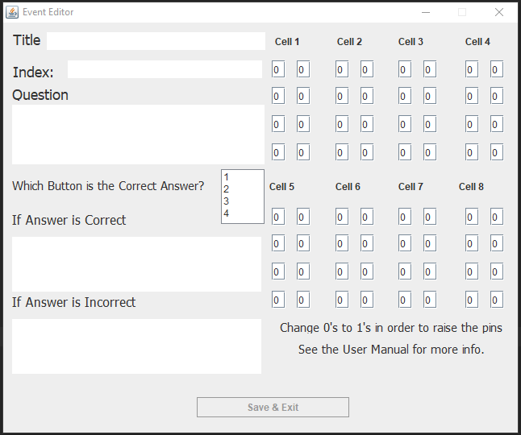

The Title of your event is merely a way for you to personalize and track each Event’s name in the Timeline, as that is what is displayed in the Event Timeline in the Scenario Editor. The Index field expects an integer as input and determines where in the Timeline you want this particular Event to be. Thus, the Index of an Event is effectively it’s ‘position’ in the Scenario relative to every other Event. You may even edit the Index of one event to be the same as another, and the timeline will insert the Event at said index and re-order all successive events down the timeline, maintaining the chronology of the Scenario.

Any text entered in the Question field will be read aloud to the user during the Scenario. You must select which button will lead to the correct answer. You may also specify that something be said if the user answers correctly or incorrectly by using the respective “If Answer is Correct/Incorrect” text fields.

Lastly, you may customize what the on-screen Braille Cells look like. Each individual pin on each cell can be controlled on the right side of the Event Editor as shown above. The state of each pin is controlled in a binary fashion, with “0” meaning the pin is lowered, and “1” meaning the pin is raised. By default, all pins are set to be lowered.

# Editing and Deleting Events

To edit or delete an Event, you must select it from the Timeline by clicking on it. This will enable the selection of “Edit Event” and “Delete Event” from under the Timeline. We added some placeholder events to the Timeline and chose to edit the Event titled “First Question.”

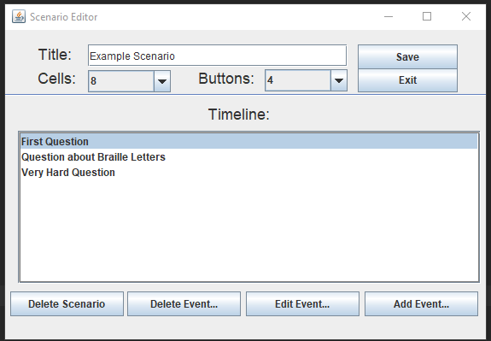

The selected event will be highlighted in blue. Notice how the delete and edit buttons are no longer greyed out. Upon clicking “Edit Event” we will be taken back to the Event Editor, and it will be populated with information about the selected Event.

###### Braille Cell Info There are always 8 cells available for you to edit in the Event Editor, regardless of how many cells you’ve chosen to display in the Scenario Editor. You may edit the values in all 8 cells, but if you have not chosen to have 8 cells displayed in the Scenario Editor, then the Cells won’t be visible to the user when they play your Scenario.

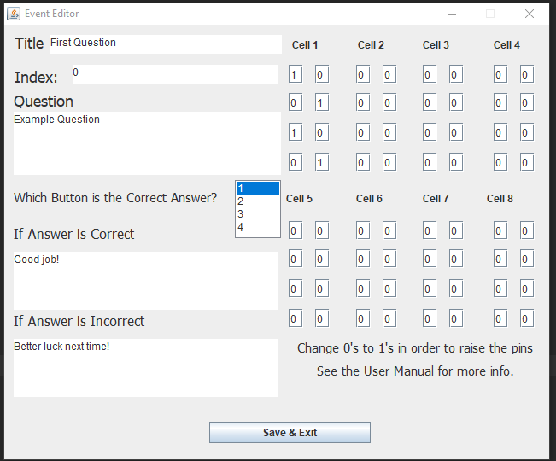

From here, we may edit any properties we want about the Event. After clicking “Save & Exit” the Event Editor will close and the changes will be saved to the Timeline. In our case, we edited the Index of the event from 0 to 3, and as such, we can see this change manifest itself in the Timeline as “First Question” has now moved down.

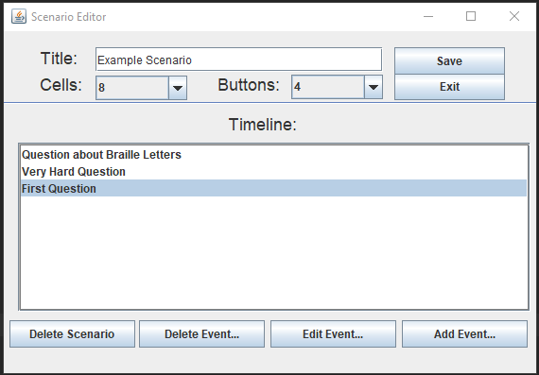

If we select “Delete Event” then we can also see the timeline change immediately:

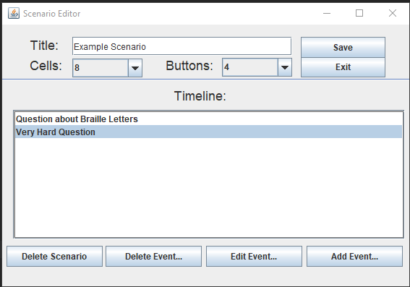

The Scenario Editor and Event Editor provide a powerful and robust way for you to create custom, engaging Scenarios for users. By selecting “Save” you will be prompted with a standard save file dialog. The file created can then be used as a Scenario in TBB applications.